|  |  |  |
| --- | --- | --- |
| **Pondtype** | **Thermalsums** | **ponds** |
| Very early | 6.7 | NoOil |
| Early | 27.25 | Oil, Black |
| Average | 40.875 | Vulgaris, East, Ice, |
| Later Average | 44.5 | SBS, Seahorse, Shotgun |
| Later | 61.33333333 | Experiment, Vulgaris small |
|  |  |  |

**Dates when larvae were <02.mg**

**Based on Thermal sums from (1974-2017) and (2000-2017)**

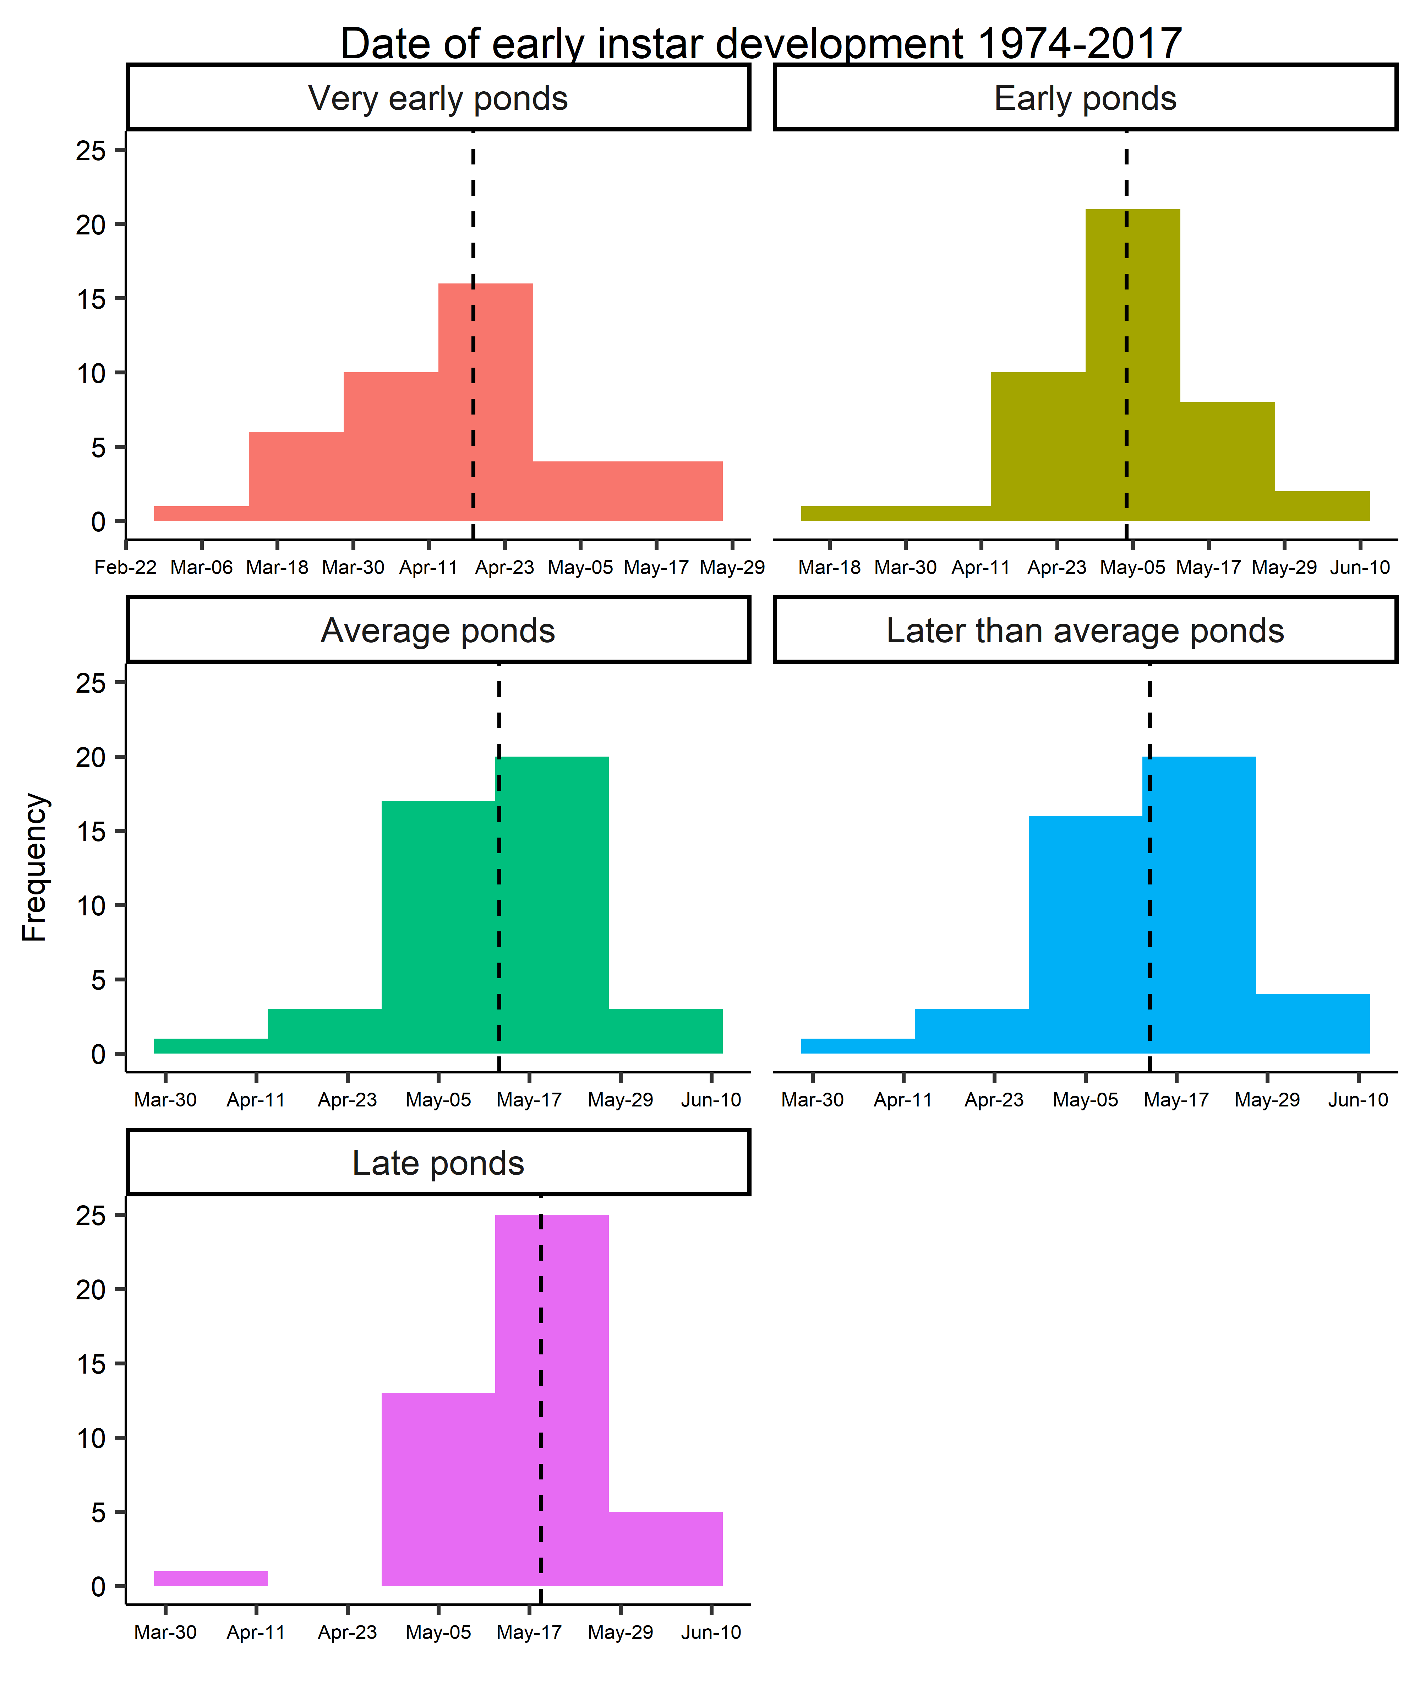 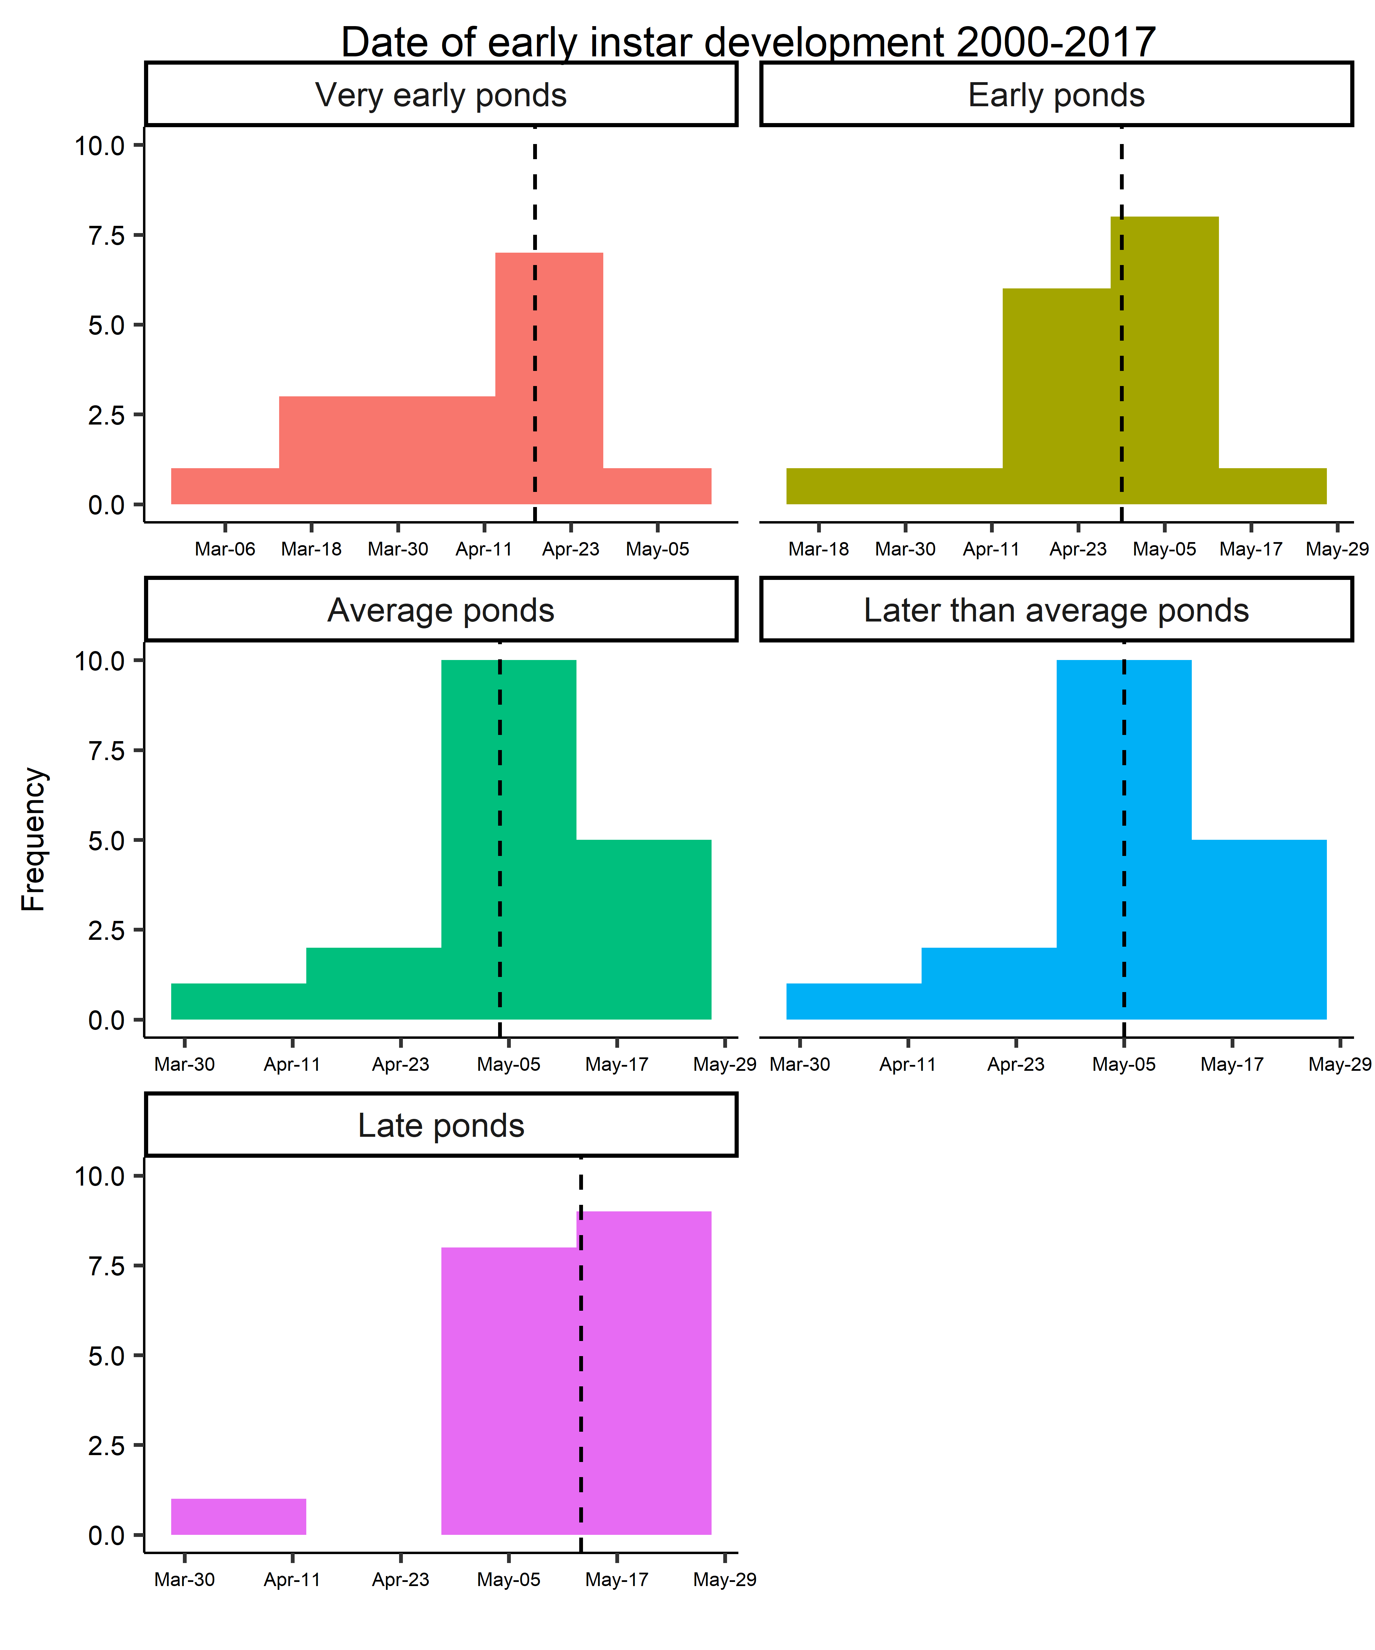

**Median dates**

**Apr 29 for early ponds**

**May 04 for average ponds**

**Median dates**

**May 04 for early ponds**

**May 13 for average ponds**